CALL FOR ARTISTS

Burke-Gilman Playground Park Project

Opportunity for Artist to Join Landscape Architect-Led Design Team

Dear Artists,

The Eli’s Park Project is looking for an artist to join the design team for the planning phase of our project to plan and design an accessible, inclusive, nature-based park space where the Burke-Gilman Playground Park currently sits.

If you are interested in being considered for this project, please email your intent to apply and qualifications to Paige Reischl at pmreischl@gmail.com along with a letter of interest specific to the scope of work (listed below) by 5 p.m. (PDT), Friday, November 2nd.

PROJECT BACKGROUND
The Eli’s Park Project in partnership with Seatle Parks and Recreation, Seattle Department of Neighborhoods, Seattle Parks Foundation, landscape architecture firm (TBD) and community are looking for an artist to join landscape architect-led design team to develop a plan to include site-specific or site-integrated artwork and a welcoming, inclusive plan.

The Eli’s Park Project received a Neighborhood Matching Fund award to renovate The Burke-Gilman Playground Park in partnership with Seattle Parks and Recreation, Seattle Department of Neighborhoods, Seattle Parks Foundation and the community. The park lies in close proximity to The Ronald McDonald House and Seattle Children’s Hospital. It also serves residents of The Burke-Gilman Place Apartments, Capitol Hill Housing and Provail Housing. Because of the park’s unique location and the diversity of age, class, race, ability and medical conditions among residents and visitors, priorities for the renovation are: accessible, inclusive, nature-based, welcoming, peaceful and community-led.

The Eli’s Park Project team is a group of volunteers who are committed to creating an inclusive, nature-based park space so that people of all ages and abilities can access play and peace together in the outdoors. We are committed to authentic community outreach and intend the collected feedback to be used to inform and shape the design plan.

SCOPE OF WORK
The selected artist will join the landscape architect-led design team to work with our community to create an innovative design plan for The Burke-Gilman Playground Park renovation. Artistic elements and features should help define the space as a public park, increase sense of welcoming and belonging for our diverse community and enhance the user experience around the park space.

The selected artist/s will contribute to a schematic design plan that includes artful elements for a variety of purposes. Artistic design and features may be used to define space, provide beautiful elements and features, encourage exploration and activity, teach visitors about the history and/or intention of the space, connect the public to the local environment and enhance the experience for visitors of the site. The artwork elements could take the form of, but are not limited to, freestanding sculptures, signage, and/or surface treatments, seating and gathering spaces, playful features to be placed throughout the site, around the entrance, in focal points and along and marking the shared pathway to the trail. The selected artist/s will be encouraged to explore a diversity of media for this project.

Selected artist should know and understand the strengths and challenges of people who live in and visit the community. Artist must be willing and able to approach the project through a lens of inclusion. Race, social justice and equity should be at the forefront of a creative community engagement process. The planning phase should include several design concepts for community input and should culminate in a design plan that includes the hopes and needs of all the members of our community who this park will serve. The design must fit the long-term maintenance goals of Seattle Parks and Recreation. It is intended that the artist will carry this project through to the completion of construction.
See RFQ and design program for more details about overall project at www.elispark.org/applicants.

Statement of Belief
We believe that the more diverse our interactions, the more inclusive our world can become. The park design should allow the simultaneous use of a wide range of users to enjoy the park space together.

See also: https://www.elispark.org

Current photos of Burke-Gilman Playground Park. To be completely renovated.

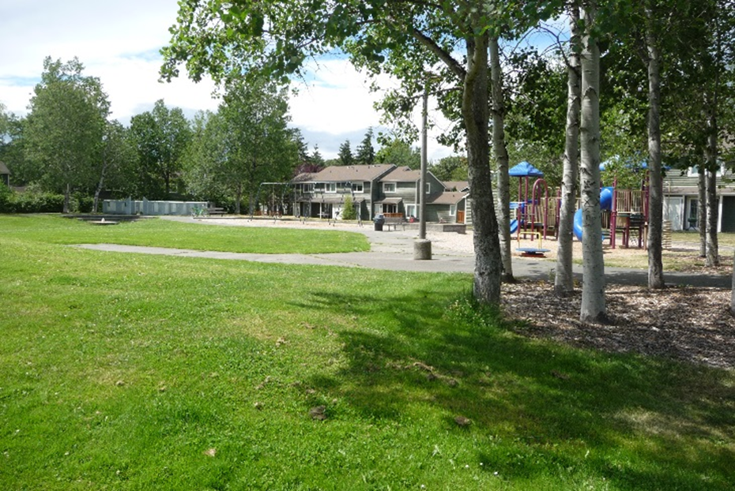
Entrance with Birch Trees

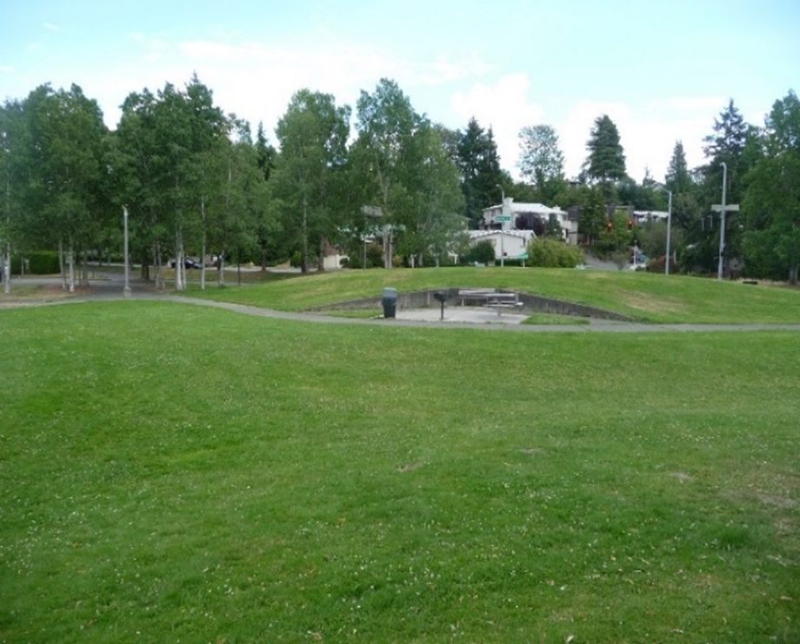
Open field with small seating and BBQ

PROJECTED TIMELINE
An artist will be selected following the hiring of a landscape architect-led design team. Landscape architects will be hired by Monday, November 19, 2018. The artist will participate in design development with the project design team, project stakeholders, and community members. All proposed art and design plans must meet Seattle Parks and Recreation requirements and be approved through a series of community meetings and a formal Proview Process.

Artist Selection – fall 2018
Design – fall 2018-fall 2019
Construction start – spring 2019
Project completion – spring 2020

Budget
The total compensation for planning phase is $4,000. Contracting will be done in two phases: $4,000 for design; TBD for fabrication and installation.

Application DEADLINE
Deadline to apply: 5 p.m. (PDT), Friday, November 2nd.

Application REQUIREMENTS
Email Paige Reischl at pmresichl@gmail.com your intent to apply along with a Eli’s Park Project Letter of Interest.
Questions may also be submitted in advance via email.

Please include your experience with and general approach to topics listed below.

Responsibilities:
- Attend meetings and collaborate with design team and community members
- Brainstorm ways to integrate art into design (include cost estimate, materials, contractor options).
- Design and present possible community outreach and interactive elements
- Champion artwork throughout the design process
- Intent to participate in future phases. (Will bring selected concepts to fruition via original artwork creation, collaboration with artist community, collaboration with contractors, etc.)

Qualifications:
- Experience with and enthusiasm for connecting the public to natural surroundings
- Experience creating curriculum and/or outreach related to art and nature
- Willingness to collaborate with contractors, design team, leadership team, community, students
- Commitment to include a diversity of artists and volunteers throughout process
- Artwork that is currently recognized and synonymous with our region

Selection Criteria
The artist will be selected on the basis of the following criteria:
- Quality of concept, design, and craftsmanship of past works
- Creativity of approach
- Relevance of Letter of Interest
- A proven ability to coordinate and collaborate with project managers, design professionals and community stakeholders
- The ability to produce durable outdoor art

Selection Process
The selection will take place in two parts. During the first round of the selection process, a panel consisting of Eli’s Park Project professionals, a representative from landscape architect team and a community member will review the applicants’ images, qualifications, and other materials. The panelists will identify up to three finalists to interview. During the second round of the selection process, finalists will be interviewed and a panel will select one artist to be awarded the commission. Applicants will be notified of results within a week of interviews.

We’re here to help!
Please contact Paige Reischl, Project Lead, at pmreischl@gmail.com for questions related to The Eli’s Park Project call for artist.

